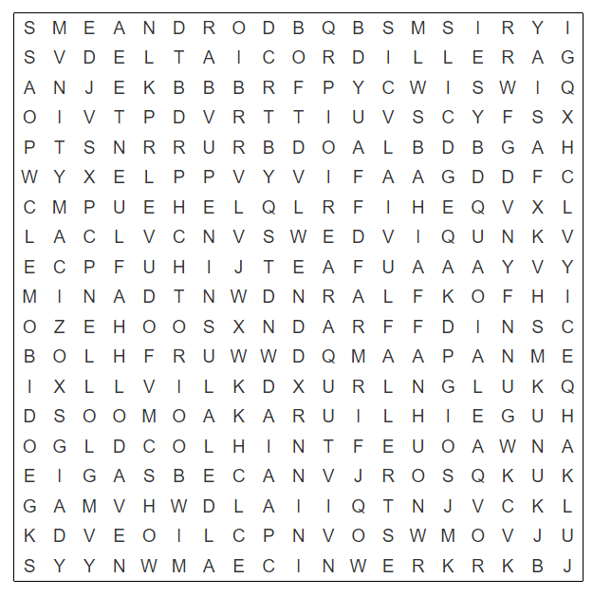
EL RELIEVE – SOPA DE LETRAS
Encuentra las 16 palabras escondidas en la sopa de letras y con cada una escribe una oración sobre el relieve.

- ______________________________
- ______________________________
- ______________________________
- ______________________________
- ______________________________
- ______________________________
- ______________________________
- ______________________________
- ______________________________
- ______________________________
- ______________________________
- ______________________________
- ______________________________
- ______________________________
- ______________________________
- ______________________________

CON LAS 16 PALABRAS DE LA SOPA DE LETRAS ESCRIBE ORACIONES DONDE USES CADA UNA:

- _________________________________________________________________________________________
- _________________________________________________________________________________________
- _________________________________________________________________________________________
- _________________________________________________________________________________________
- _________________________________________________________________________________________
- _________________________________________________________________________________________
- _________________________________________________________________________________________
- _________________________________________________________________________________________
- _________________________________________________________________________________________
- _________________________________________________________________________________________
- _________________________________________________________________________________________
- _________________________________________________________________________________________
- _________________________________________________________________________________________
- _________________________________________________________________________________________
- _________________________________________________________________________________________
- _________________________________________________________________________________________

